1. What is the difference between ls , ls -l , and ls -a ? Provide examples.

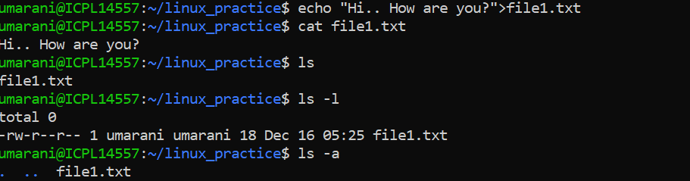

2. How can you display the contents of a directory sorted by file size using ls ?

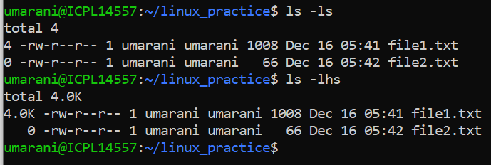

3. Explain the purpose of the ls -i option and its practical use.

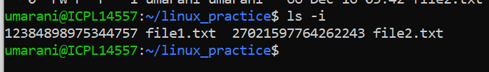

4. How can you use ls to only list files with a specific extension (e.g., .txt )?

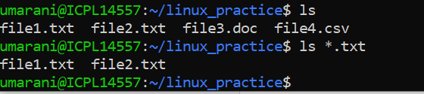

5. How do you display the human-readable file sizes in the output of ls ?

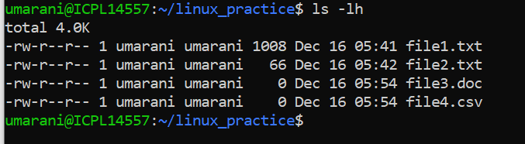

6. How can you use ls to display hidden files in a directory?

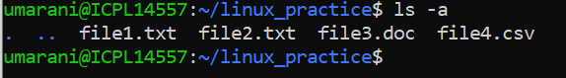

7. What is the difference between ls -R and ls -d */ ?



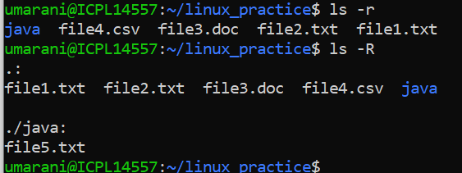

8. How would you use ls to display file types (e.g., directories, regular files, symbolic links)?

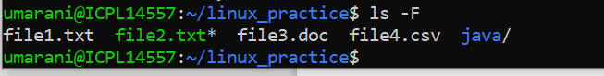 here green color file indicates that file having excutable perm also and blue color indicATES THE directory.

9. What does cd .. do? How is it different from cd ../.. ?

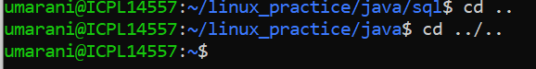

10. Explain the behavior of cd - . Why is it useful?

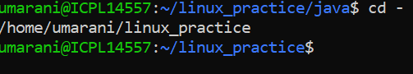

11. What happens when you run cd without any arguments?

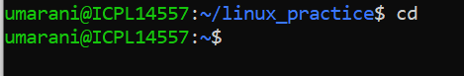

12. How can you navigate to a directory with spaces in its name using cd ?

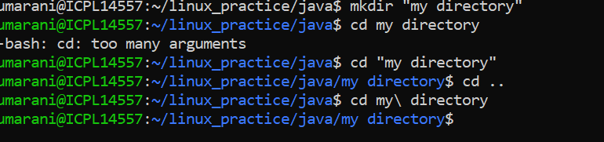

To rename the directory mv "my directory" my_directory.

13. Describe a situation where using an absolute path in cd is better than using a relative path.

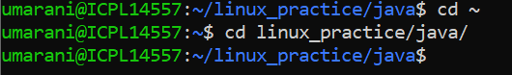

14. What is the difference between cd ~ and cd $HOME ? Are they always equivalent?

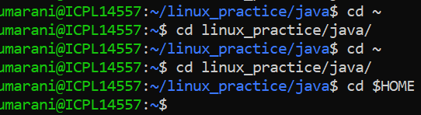

15. How is the output of pwd different from pwd -P ? Provide examples.

16. What is the significance of pwd in shell scripting?

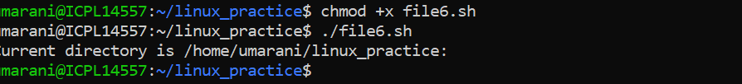

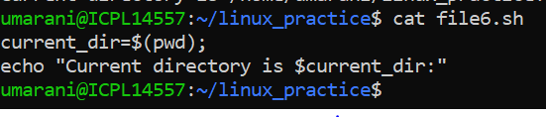

19. How can you create a directory along with its parent directories in one command? Use -p :

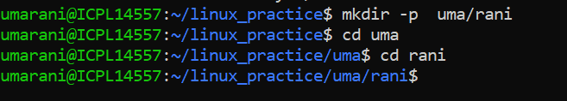

20. What happens if you try to create a directory that already exists using mkdir ? How can you suppress the error message?

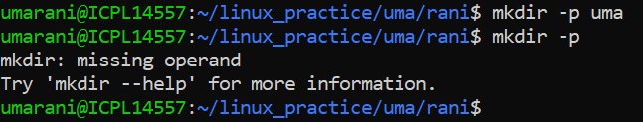

21. Explain the purpose of the -m option in mkdir . How would you use it to set specific permissions on a directory during creation?

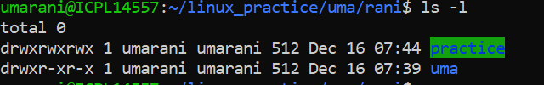

22. How can you use mkdir to create multiple directories at once (e.g., dir1, dir2, dir3)?

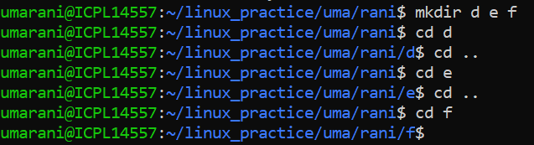

23. Explain the difference between rm filename , rm -r directory , and rm -rf directory .

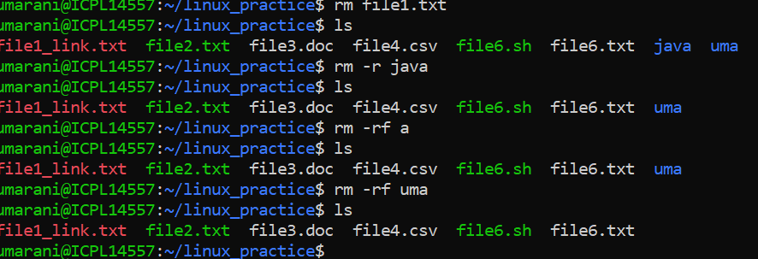

25. How can you use rm interactively to confirm file deletion?

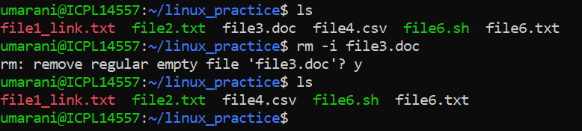

26. How would you remove all files with a specific extension (e.g., .log ) in the current directory using rm ?

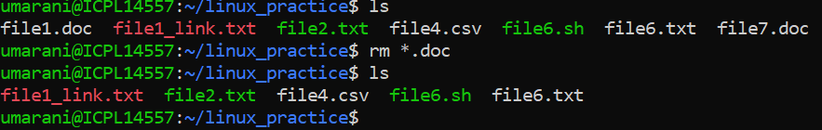

27. What is the difference between rm -i and rm -f ? When would you use each?

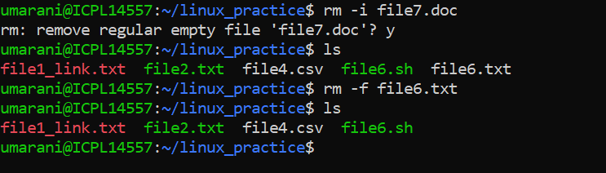

28. How can you ensure that rm does not accidentally delete files by enabling a safety mechanism?

